ThreatMap - Network Attack Simulation and Visualization
Submission-ready Cisco Packet Tracer report with validated attack-response evidence, professional topology layout, screenshots, security controls, and final verification results.

Executive Summary
This project demonstrates a professional cybersecurity network simulation using Cisco Packet Tracer. The topology includes attacker zones, protected servers, legitimate clients, centralized logging, DHCP protection, ACL-based filtering, SSH management security, and MAC flooding mitigation.

1. Final Professional Network Topology
The topology was redesigned into a cleaner and more professional segmented structure. Each security zone is visually separated to improve readability and presentation quality.
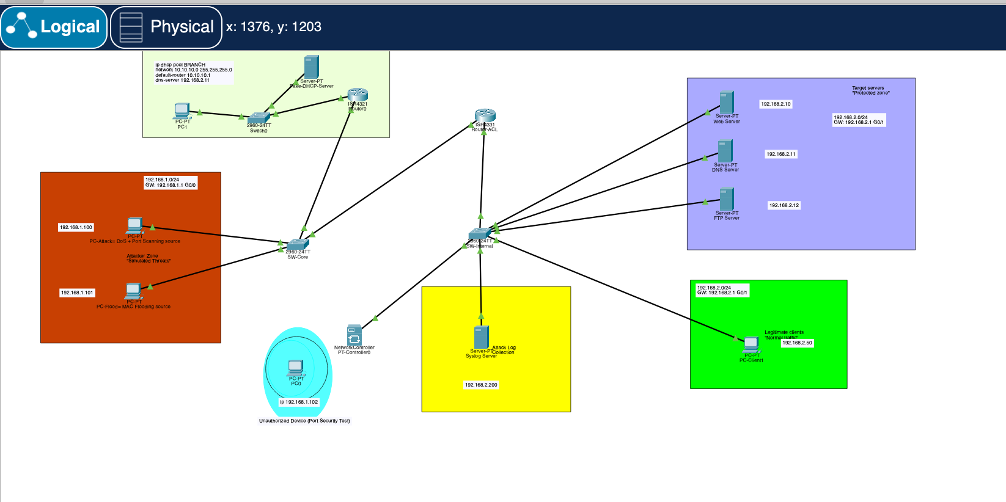
Figure 1. Final ThreatMap professional topology design.

2. Updated Drafting Plan and Security Zones
Zone | Subnet | Purpose | Gateway
Attacker Zone | 192.168.1.0/24 | DoS + Port Scanning + MAC Flooding simulation | 192.168.1.1
Protected Servers | 192.168.2.0/24 | DNS / Web / FTP services | 192.168.2.1
Legitimate Clients | 192.168.2.0/24 | Normal trusted traffic | 192.168.2.1
DHCP Branch | 10.10.10.0/24 | Dynamic addressing branch network | 10.10.10.1
Logging Zone | 192.168.2.200 | Centralized Syslog collection | 192.168.2.1

3. Added Security Controls and Validations
- ANTI-DOS extended ACL successfully blocks ICMP attack traffic.
- TCP administrative ports 22, 23, and 3389 are protected.
- SSH management access is tested and verified.
- DHCP Snooping is enabled on SW-Core.
- Fake DHCP Server attack simulation is included.
- OSPF neighbor relationships are operational.
- Syslog logging server receives network events.
- Port Security mitigates MAC flooding attacks.
- Normal client traffic remains operational after ACL deployment.

4. Detailed Validation Screenshots

ACL Match Counter Verification
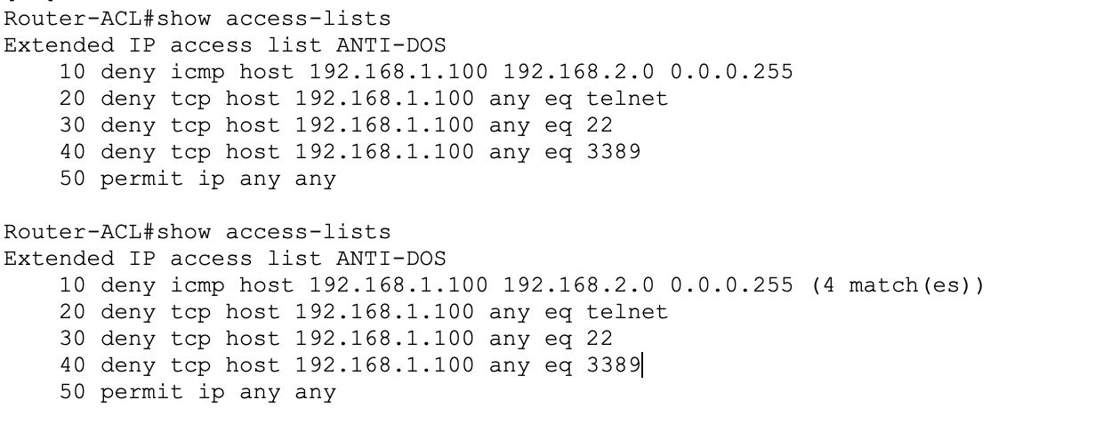
This screenshot provides validation evidence for "ACL Match Counter Verification" and confirms the expected security behavior during testing.

DoS-style Attack Blocking
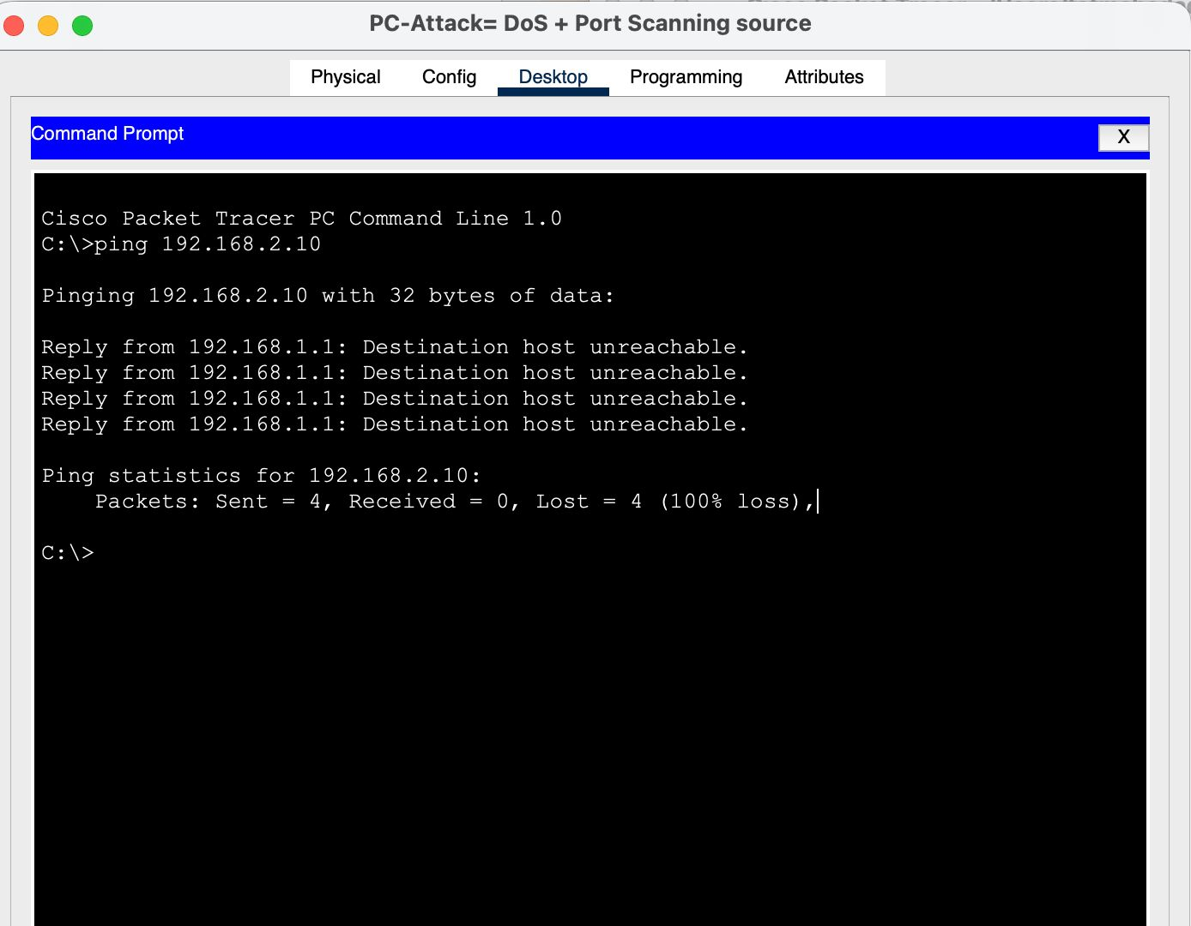
This screenshot provides validation evidence for "DoS-style Attack Blocking" and confirms the expected security behavior during testing.

DHCP Snooping Configuration
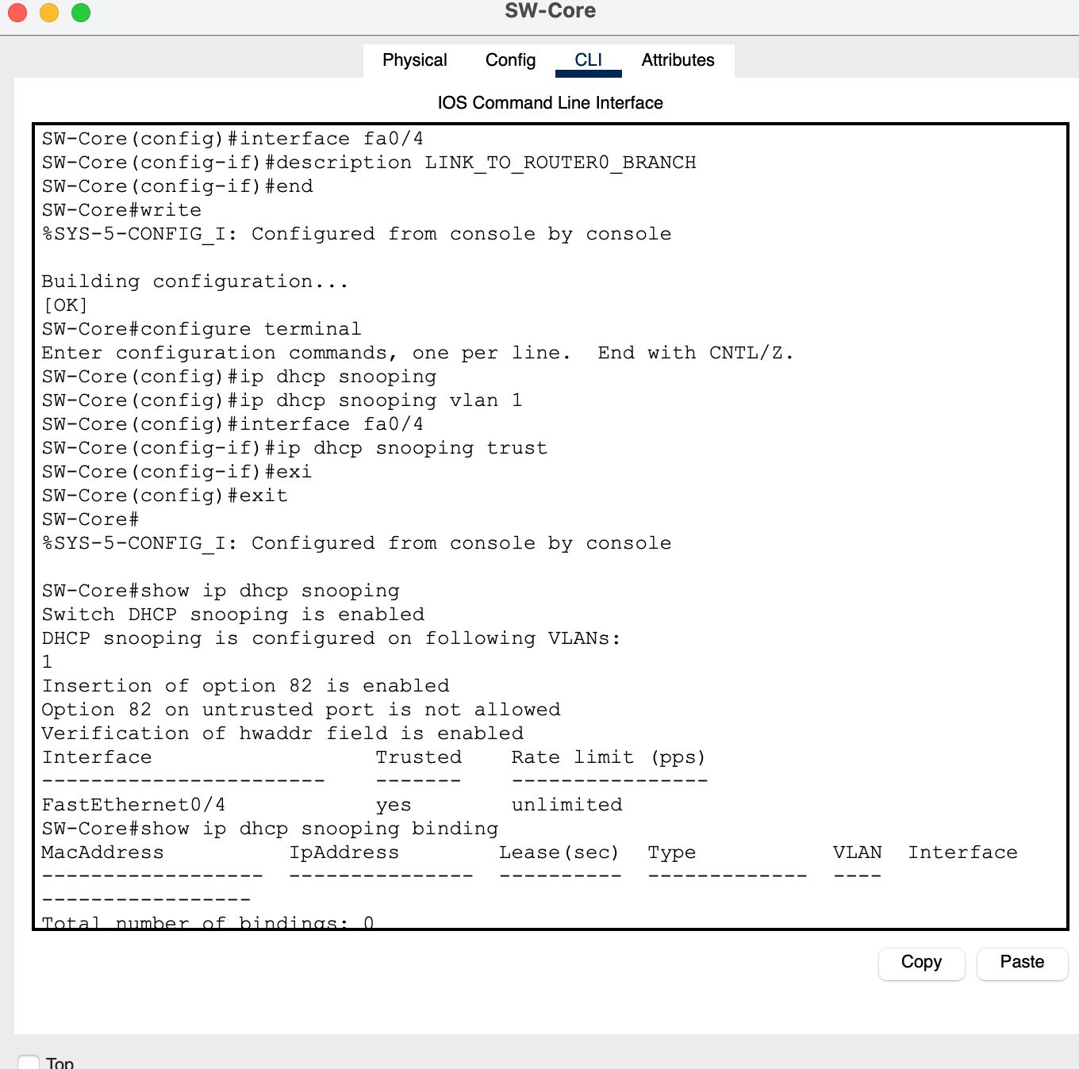
This screenshot provides validation evidence for "DHCP Snooping Configuration" and confirms the expected security behavior during testing.

Routing and OSPF Verification
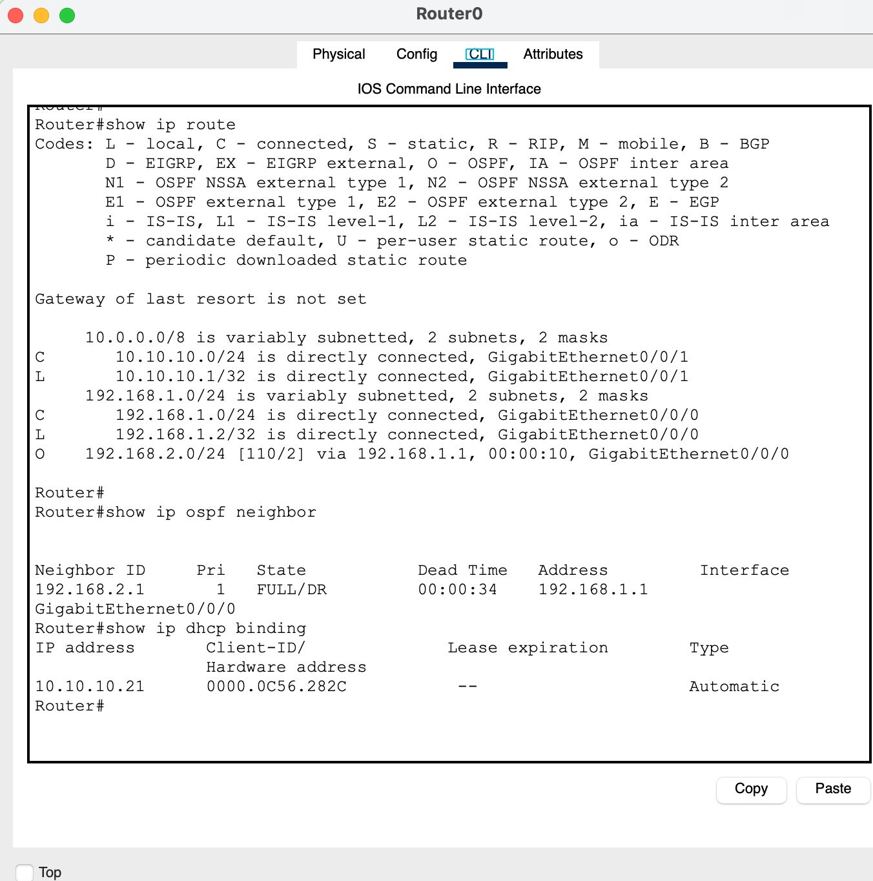
This screenshot provides validation evidence for "Routing and OSPF Verification" and confirms the expected security behavior during testing.

DHCP Client Verification
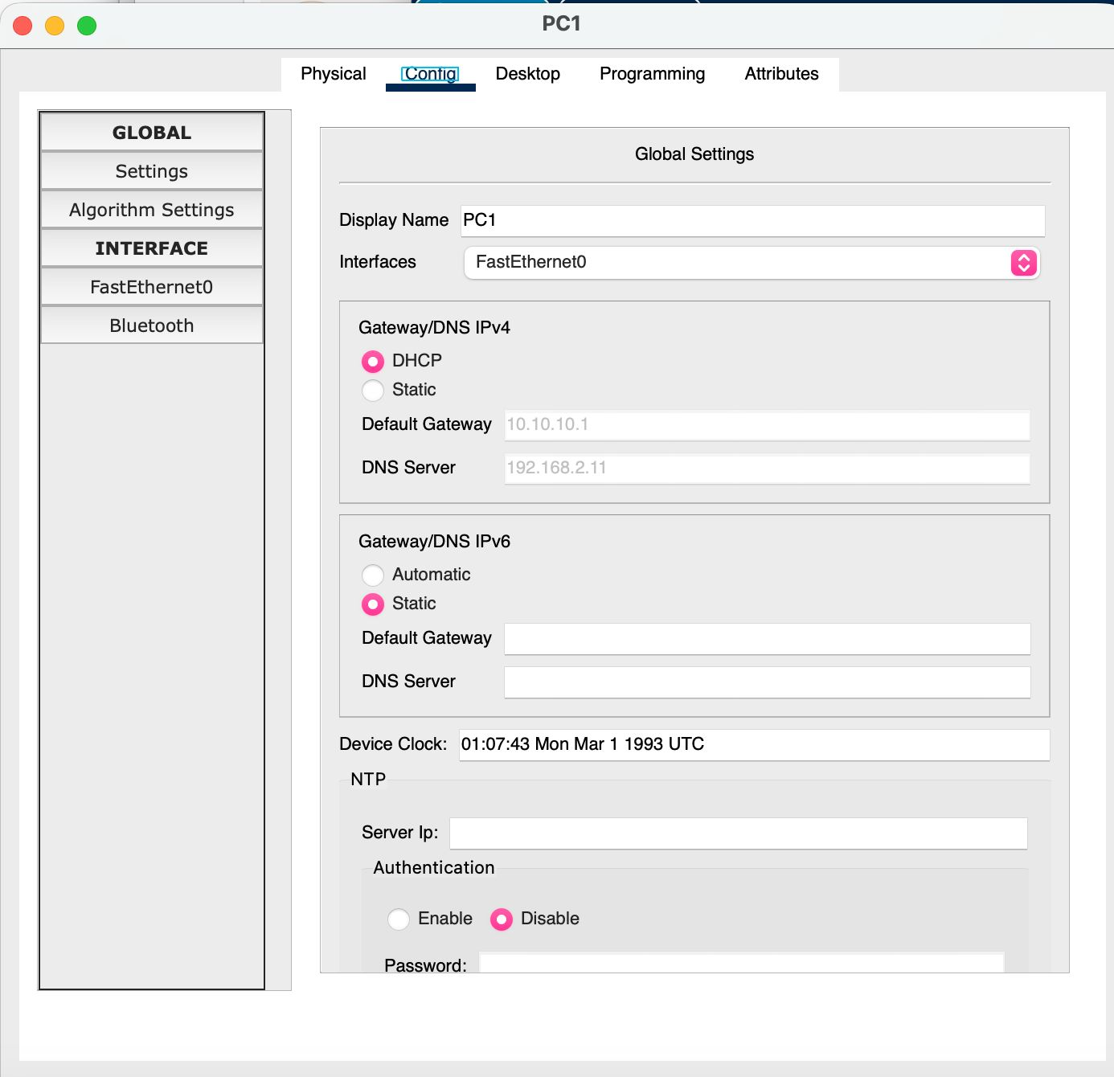
This screenshot provides validation evidence for "DHCP Client Verification" and confirms the expected security behavior during testing.

SSH and ACL Security Verification
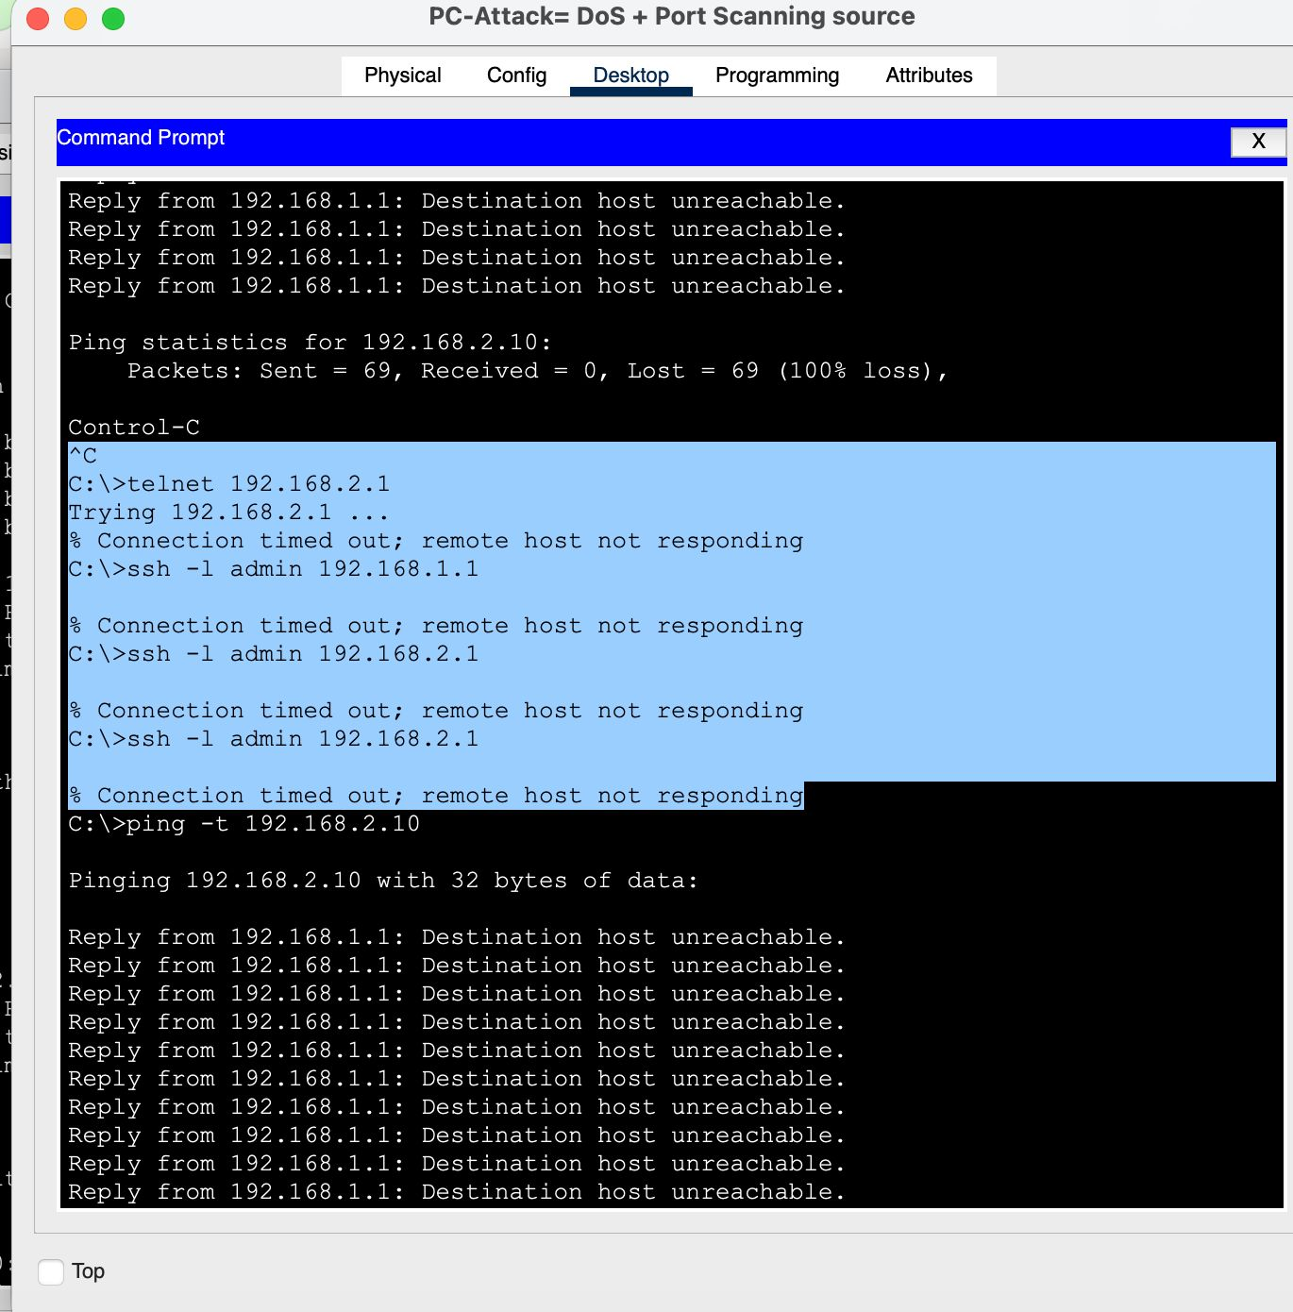
This screenshot provides validation evidence for "SSH and ACL Security Verification" and confirms the expected security behavior during testing.

Continuous Attack Failure
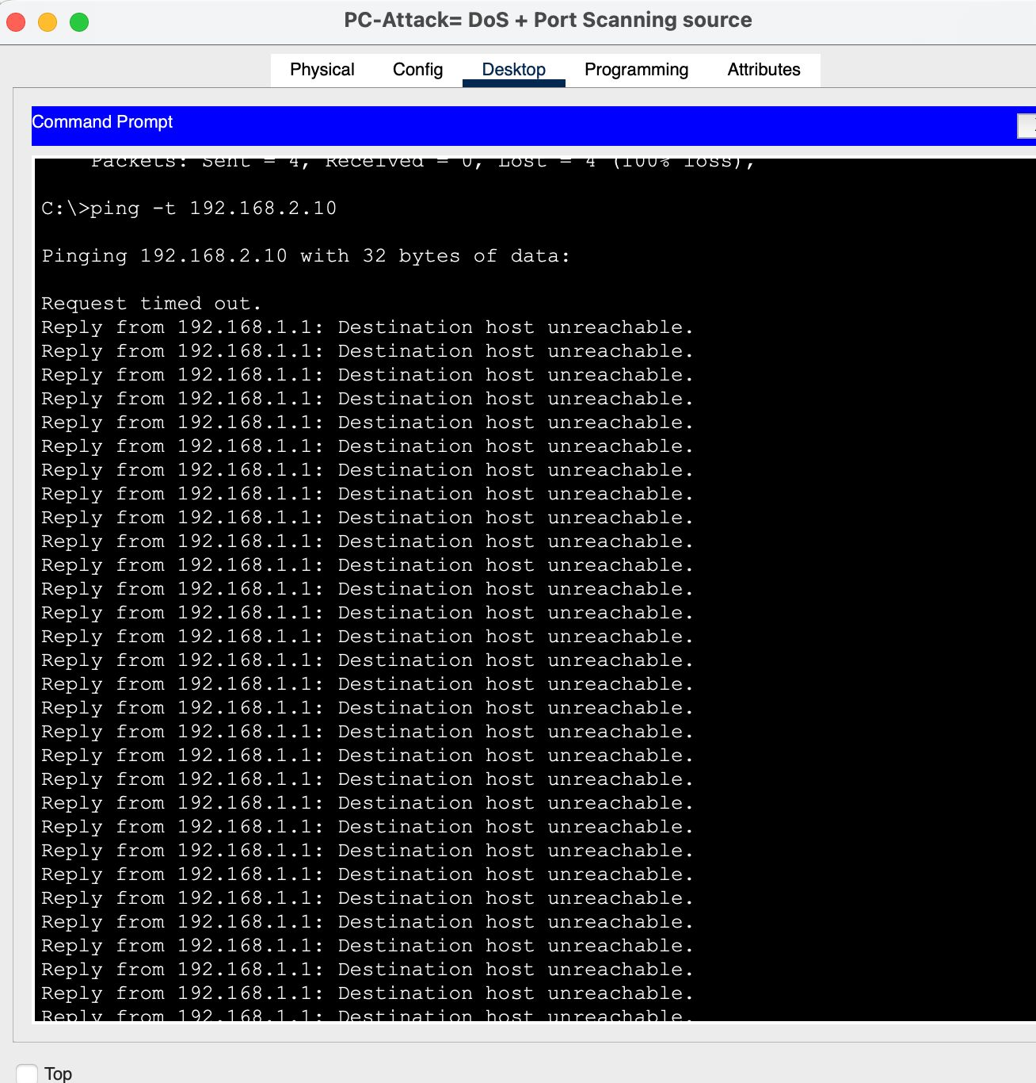
This screenshot provides validation evidence for "Continuous Attack Failure" and confirms the expected security behavior during testing.

Fake DHCP Server Simulation
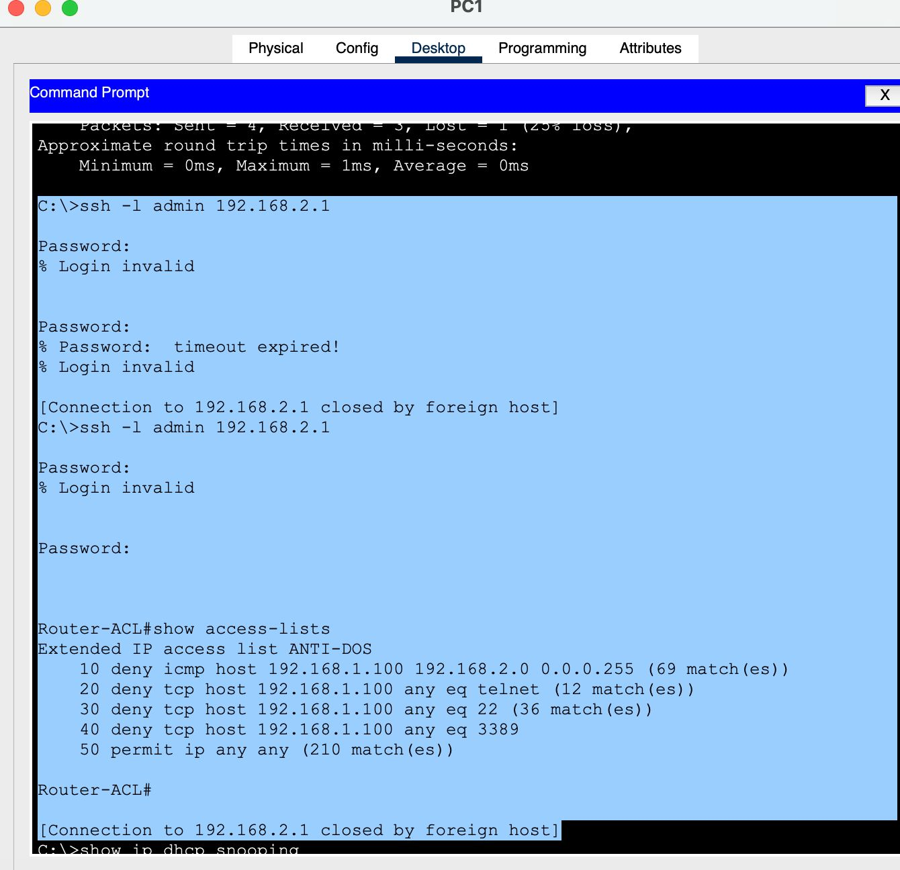
This screenshot provides validation evidence for "Fake DHCP Server Simulation" and confirms the expected security behavior during testing.

5. Final Validation
The final validation confirms that the entire ThreatMap project is operational and professionally organized for submission.
• The topology is segmented and visually organized.
• ACL rules actively block hostile ICMP and management traffic.
• SSH access control is implemented and tested.
• DHCP Snooping protects against rogue DHCP servers.
• MAC Flooding mitigation is operational through Port Security.
• Syslog logging captures supported security-related events.
• OSPF routing functions correctly between routers.
• Legitimate traffic remains functional while attack traffic is blocked.
• The project includes screenshots, validation evidence, and professional documentation.

